VPC LAB

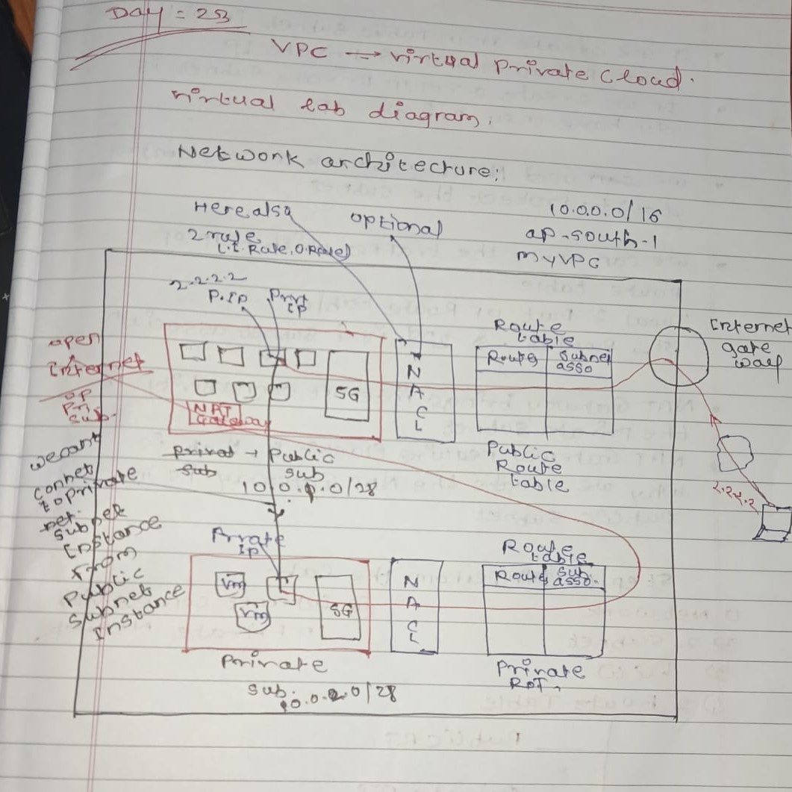
- Create a VPC
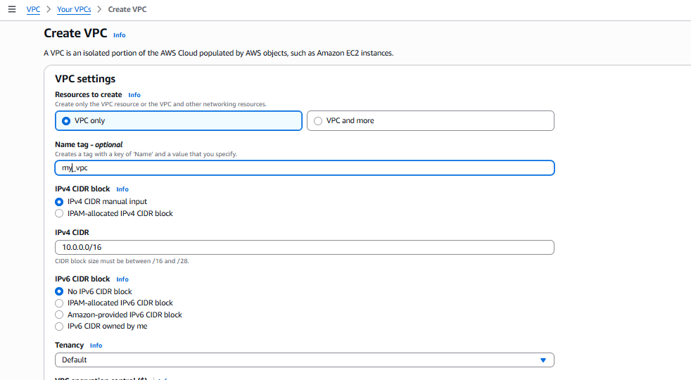
VPC has been created
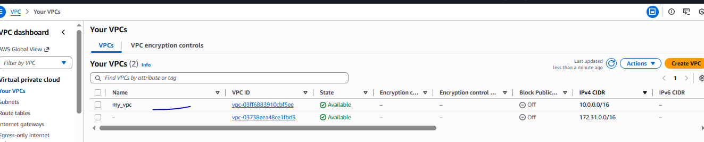

- Need to create two subnet one is public and second is private
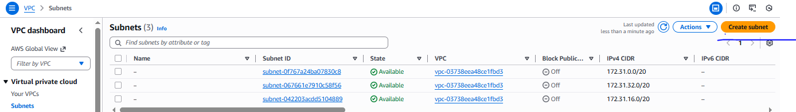
Public subnet

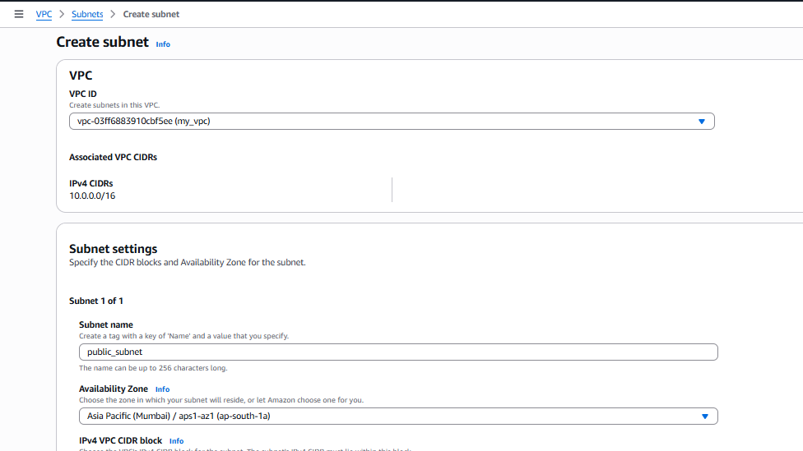

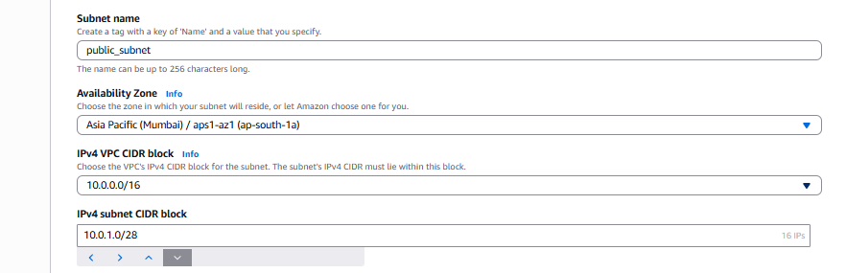
Similarly create private subnet also with same configuration of public only change the CIDR block IP for private IP need to put 10.0.2.0/28
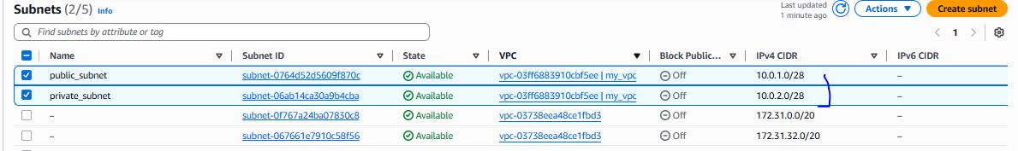
- Create a two route table one for public_RT and second for private_RT
Public_rt
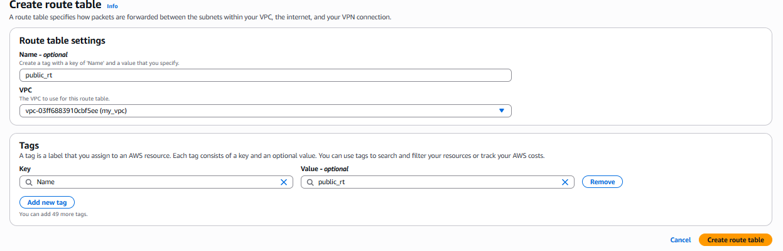

Private_rt
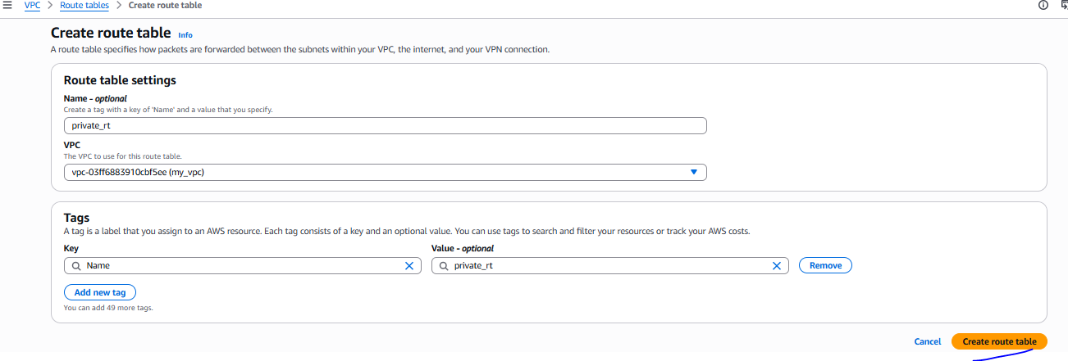

Route table has been created
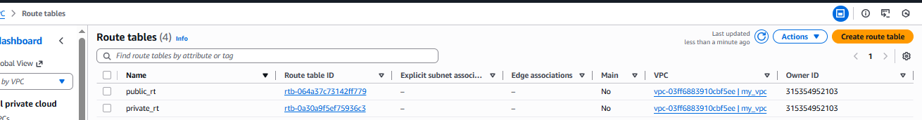

- Create the internet Gateway with custom VPC
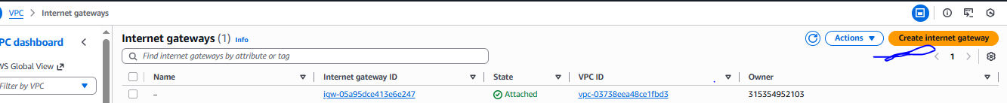

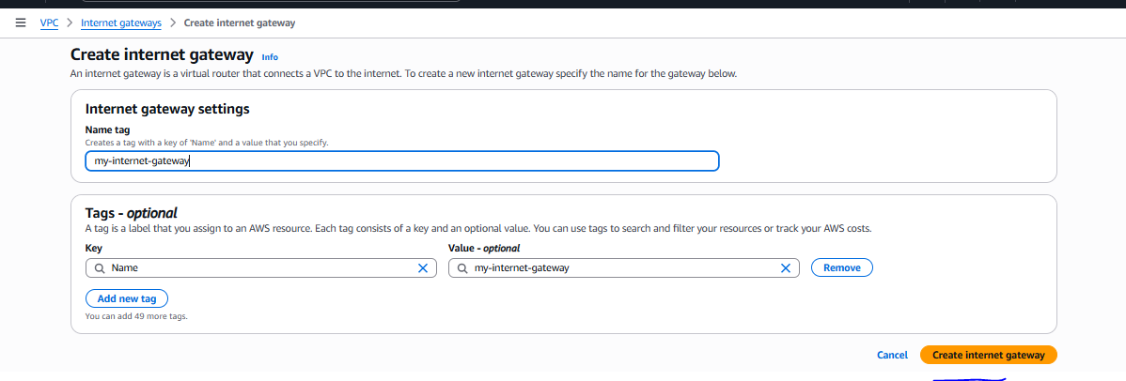
Once ICG created need to attached to custom vpc
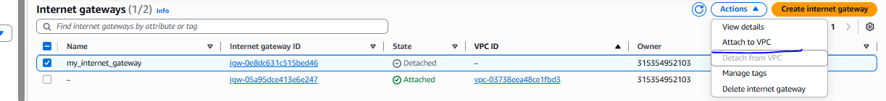
ICG attached to VPC
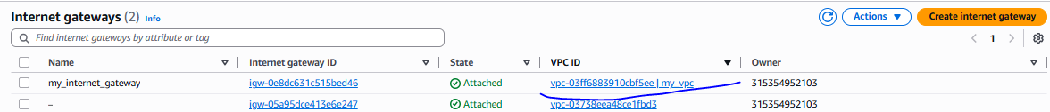

- Create NAT gateway
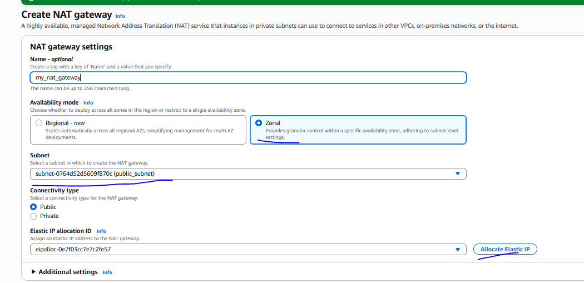

Once NAT gateway created need to configure both route tables with routes and subnet association.
- Public route table
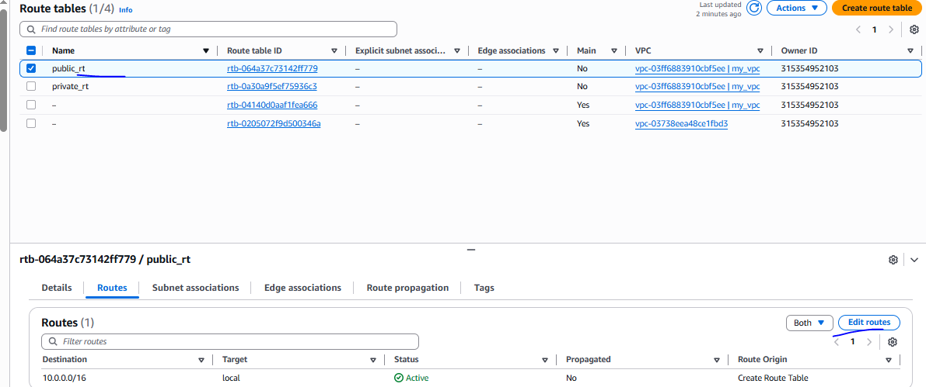
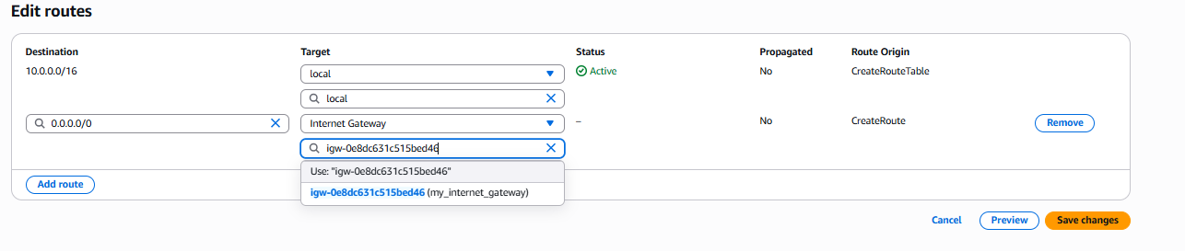
Subnet association
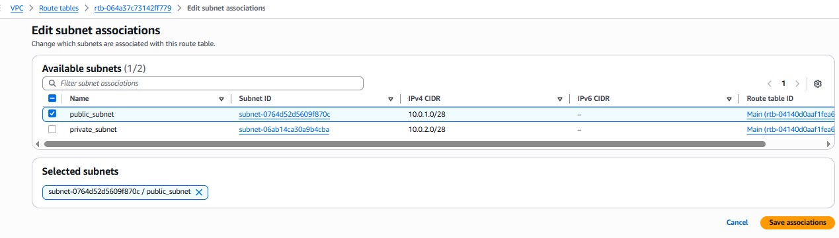

Private route table
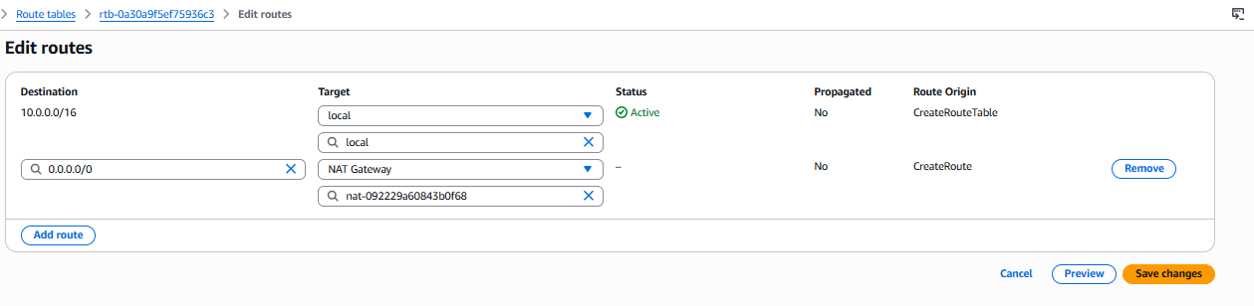
Subnet association for private
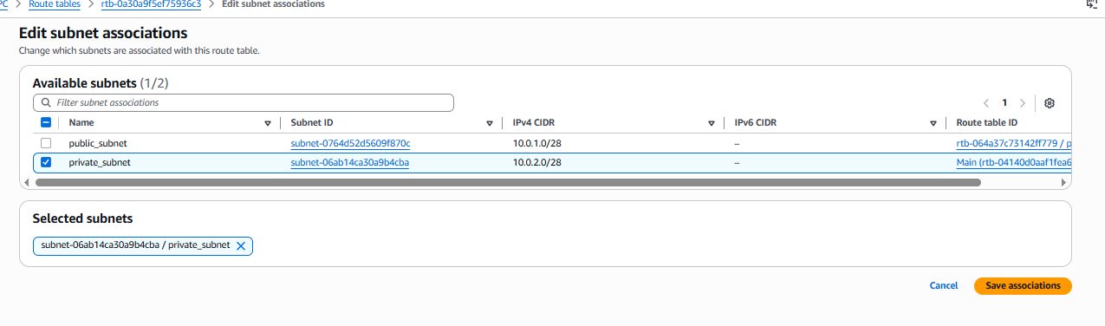
6,7,8,9) Create two instance, one is for public subnet and 2nd for private subnet

While creating the instance need to change the VPC setting for private as mention below, and for public should be subnet is public and auto assign setting is enabled
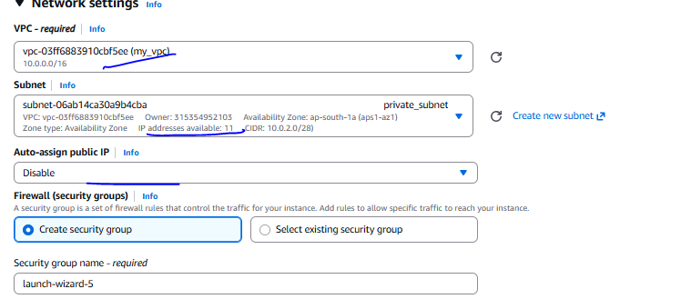
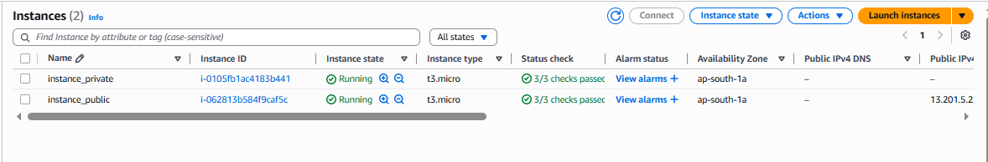

10) verified
Network connectivity present on public subnet instance
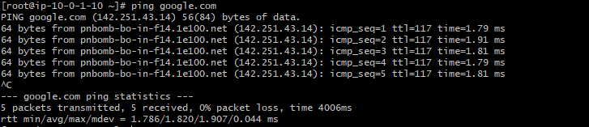

How to jump on private
Open the .pem key
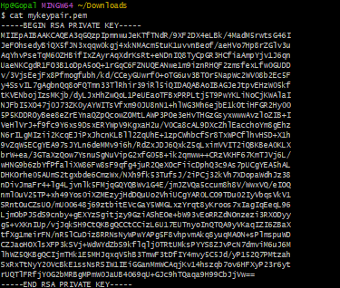

Once login public subnet instance please copy the pem key in new file to login the private network server
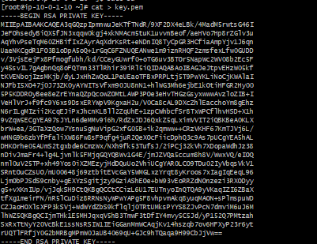

Able to login on private_subnet instance and also able to connect internet also
